**Project Charter Document**



**Project Name:** AI-Driven Highway Inspection and Maintenance System.

**Department:** Highway Infrastructure Management.

**Focus Area:** Road Safety Enhancement.

**Product/Process:** Automated Condition Assessment.



**Prepared By**

|  |  |
| --- | --- |
| **Document Owner(s)** | **Project/Organization Role** |
| AATHISAKTHI G | Data Scientist |
|  |  |
|  |  |
|  |  |
|  |  |
|  |  |

**Project Charter Version Control**

|  |  |  |  |
| --- | --- | --- | --- |
| **Version** | **Date** | **Author** | **Change Description** |
| 1.0 | 02/01/2021 | Aathisakthi G | Document created |
| 1.1 | 03/01/2025 | Aathisakthi G | Edited basic and project executive summary details |
| 1.3 | 13/01/25 | Aathisakthi G | Dataset related details updated before model initialization |
| 1.4 | 25/01/25 | Aathisakthi G | Model initialization details in each sections are updated |

**TABLE OF CONTENTS**

1 PROJECT CHARTER PURPOSE 3

2 PROJECT EXECUTIVE SUMMARY 3

3 PROJECT OVERVIEW 3

4 PROJECT SCOPE 4

4.1 Goals and Objectives 4

4.2 Project Deliverables 4

4.3 Deliverables Out of Scope 4

4.4 Project Duration 4

5 PROJECT CONDITIONS 5

5.1 Project Assumptions 5

5.2 Project Issues 5

5.3 Project Risks 5

5.4 Project Constraints 5

6 Project Structure Approach 6

7 Project Team Organization Plans 6

8 PROJECT REFERENCES 6

9 APPROVALS 6

10 APPENDICES 8

10.1 Document Guidelines 8

10.2 Project Charter Document Sections Omitted 8

# PROJECT CHARTER PURPOSE

The project charter defines the scope, objectives, and overall approach for the work to be completed. It is a critical element for initiating, planning, executing, controlling, and assessing the project. It should be the single point of reference on the project for project goals and objectives, scope, organization, estimates, work plan, and budget. In addition, it serves as a contract between the Project Team and the Project Sponsors, stating what will be delivered according to the budget, time constraints, risks, resources, and standards agreed upon for the project.



# PROJECT EXECUTIVE SUMMARY

* Problem Statement

The client, a highway maintenance contractor, faces challenges in ensuring road safety due to manual inspections being time-consuming, costly, and prone to errors. Delays in defect identification, such as faded lane lines or damaged barriers, increase safety risks. Implementing Al can automate inspections, enhance accuracy, and speed up maintenance, reducing costs and improving safety.

* Objectives
  + Business Objective: Minimize manual inspection cost.
  + Business Constraints: Maximize scalability and performance.
  + Success criteria:
    - Business Success Criteria: To detect road safety features given any highway in India.
    - Machine Learning Success Criteria: Achieve model accuracy greater than 90%.
    - Economic Success Criteria: Reduce manual inspection costs.
* Scope

The project aims to automate the detection of road safety features such as lane lines and barriers using AI. The system will be deployed in real-world highway environments and integrated into existing maintenance workflows for real-time insights. The model will be designed to adapt to different weather conditions, lighting variations, and road types, ensuring scalability across multiple regions and highway networks.

* Assumptions

It is assumed that the model will be trained on a diverse dataset representing various highway conditions in India. The availability of sufficient labeled data for training and validation is critical. The client is expected to provide the necessary infrastructure for model deployment and testing. The AI system will be periodically updated to improve performance based on new data, and the solution will comply with government regulations and safety standards.

* Risks

Several risks may impact the project, including data quality issues, environmental challenges such as adverse weather conditions, and hardware limitations that may affect real-time inference capabilities. Regulatory compliance and operational integration are also potential challenges, as the AI system must adhere to safety standards and seamlessly fit into existing maintenance workflows.

* Costs

The cost components of the project include data collection and annotation, model development and training, infrastructure setup for deployment, and ongoing maintenance and updates. Additionally, regulatory compliance costs must be accounted for to ensure adherence to legal and safety requirements.

* Timeline

The project timeline includes multiple phases. Data collection and preprocessing are expected to take two months, followed by three months for model development and training. Validation and testing will require 20 days, while deployment and integration will take an additional two months. Continuous performance monitoring and updates will be an ongoing effort.

* Approach

The approach consists of several stages. Initially, high-resolution images from highway inspections will be collected and annotated for model training. The YOLOv8s-seg model will be developed and trained with diverse highway datasets, optimized for high accuracy and real-time performance. The model will be evaluated using metrics such as mAP, IoU, and F1-score, and tested in real-world conditions. Deployment will involve implementing inference pipelines on cloud or edge devices, ensuring real-time operation and integration with highway monitoring systems. Continuous monitoring and periodic retraining will ensure sustained model performance.

* Organization

The project team comprises multiple roles, including a project manager overseeing execution, AI/ML engineers developing the model, data scientists handling preprocessing and feature engineering, software engineers managing deployment and integration, a quality assurance team ensuring model accuracy, and a regulatory compliance team maintaining adherence to s



# PROJECT OVERVIEW

working on a project for a highway maintenance contractor that aims to automate the inspection of road safety features like lane lines and damaged barriers. The goal is to reduce manual inspection costs while ensuring scalability and high performance for large-scale operations. For this, you're using AI, specifically YOLOv8s-seg, a state-of-the-art object detection model, to identify defects in road features from images. The dataset consists of almost 10k images, which you've focused on improving in terms of both quantity and quality for optimal model training.

To achieve this, you have trained the YOLOv8s-seg model and are now focused on evaluating its performance using metrics like mAP (mean Average Precision) and IoU (Intersection over Union). You also aim to integrate OpenCV-based live video processing into Streamlit for real-time inspection.



# PROJECT SCOPE

## Goals and Objectives

|  |  |
| --- | --- |
| **Goals** | **Objectives** |
| * Develop an AI-powered system to identify and assess road safety features such as lane lines and damaged barriers, reducing dependence on manual inspections. * Train and optimize the YOLOv8s-seg model to achieve high accuracy in detecting road safety elements, ensuring a **minimum accuracy of 90%**. * Integrate OpenCV-based live video processing within Streamlit to enable real-time assessment of road conditions for efficient maintenance planning. * Design the solution to function effectively across different highway environments, considering variations in lighting, weather conditions, and road types. * Minimize the cost of inspections by automating defect detection, reducing the need for human intervention, and improving detection reliability. * Evaluate model performance using **mAP (mean Average Precision), IoU (Intersection over Union), and F1-score**, ensuring continuous improvement. * Deploy the system efficiently, addressing challenges such as **non-stationary data distribution, hardware degradation, and system updates** to maintain accuracy over time. * Ensure that the AI system delivers explainable and user-friendly insights to highway contractors, allowing them to make informed maintenance decisions. | * Develop and fine-tune the **YOLOv8s-seg model** for detecting road safety features. * Improve dataset quality using **augmentation techniques** to enhance model generalization. * Implement **real-time video processing** using OpenCV within Streamlit for live monitoring. * Achieve a **high-performance model** that works under diverse environmental conditions. * Establish a **cost-effective and scalable deployment** strategy suitable for large-scale highway networks. * Continuously monitor and improve model accuracy through **regular updates and retraining**. * Deploy the system efficiently, addressing challenges such as **non-stationary data distribution, hardware degradation, and system updates** to maintain accuracy over time. * Ensure that the AI system delivers explainable and user-friendly insights to highway contractors, allowing them to make informed maintenance decisions. |

## Project Deliverables

|  |  |
| --- | --- |
| **Milestone** | **Deliverable** |
| * Identifying Constraints and design the project architecture, explore various public forums to collect relevant data, Data Preparation. | * Deliverable 1.1—Identifying Constraints and design the project architecture. * Deliverable 1.2—Explore various public forums to collect relevant data. * Deliverable 1.3— Data Preparation |
| * EDA and Descriptive Analytics, Model Building for Association (Fuzzy Algorithm) and Recommendation | * Deliverable 2.1— EDA and Descriptive Analytics * Deliverable 2.2— Model Building for Association (Fuzzy Algorithm) and Recommendation |
| * Model Evaluation, tuning and insights, Deployment | * Deliverable 3.1— Model Evaluation, tuning and insights. * Deliverable 3. 2— Deployment |
| * Show case and review, Final Presentation and documentation, Handover and KT. | * Deliverable4.1 – show case and review * Deliverable4.2 – Final Presentation and documentation * Deliverable4.3 – Handover and KT |

## Deliverables Out of Scope

* designs
* mobile app

## Project Duration (start date: 01/01/2025 End date: 01/02/2025)

|  |  |  |  |
| --- | --- | --- | --- |
| **Project Milestone** | **Date Estimate** | **Deliverable(s) Included** | **Confidence Level** |
| * Identifying Constraints and design the project architecture, explore various public forums to collect relevant data, Data Preparation. | [01/01/2025]  -  [12/01/2025] | * Deliverable 1.1—Identifying Constraints and design the project architecture. * Deliverable 1.2—Explore various public forums to collect relevant data. * Deliverable 1.3— Preparing and augmenting data for model training (e.g., polygon augmentation) | [High] |
| * Data Preprocessing, Model Design, and getting the dataset to yolo preferred format and initiate training. | [12/01/2025]  -  [19/01/2025] | * Deliverable 2.1—preprocessing the dataset and balancing . * Deliverable 2.2 Designing YOLOv8s-seg architecture and training the initial model. | [High] |
| * Model Evaluation, tuning and insights, Deployment | [19/01/2025]  -  [26/01/2025] | * Deliverable 3.1: Evaluating model performance (mAP, IoU metrics) * Deliverable 3.2: Model tuning (hyperparameters, learning rate) for better performance * Deliverable 3.3: Enhancing model for scalability and real-time road inspection | [High] |
| * Obtaining the best weights and deploy the model using stremlit | [27/01/2025]  -  [31/01/2025] | * Deliverable 4.1: Deploying YOLOv8s-seg model for real-time road inspection * Deliverable 4.2: Testing deployment on live video feeds and road images. | [Medium] |
| * Final Presentation and documentation, Handover and KT. | [01/02/2025]  -  [03/02/2025] | * Deliverable4.1 – Final Presentation and documentation * Deliverable4.3 – Handover and KT | [Medium] |



# PROJECT CONDITIONS

## Project Assumptions

* Work on data which is extracted from public sources.
* Can create a web API by using flask or streamlit.
* Cloud deployment should be done.
* **Robust Tested:** Application should be tested for noise data also.

## Project Issues

**Priority Criteria**

1 − High-priority/critical-path issue; requires immediate follow-up and resolution.

2 − Medium-priority issue; requires follow-up before completion of next project milestone.

3 − Low-priority issue; to be resolved prior to project completion.

4 − Closed issue.

|  |  |  |  |  |  |
| --- | --- | --- | --- | --- | --- |
| **#** | **Date** | **Priority** | **Owner** | **Description** | **Status & Resolution** |
| 1 | |  |  | | --- | --- | |  | 05/01/2025 | | High | [Owner 1] | Issue with insufficient labeled data for training the model | Resolved; Additional data collection was performed. Data augmentation techniques initiated to balance the dataset. |
| 2 | 20/01/2025 | High | [Owner 1] | Slow model training times due to resource limitations  And low mAP scores | Resolved; Training split across multiple instances of Google Colab to improve performance. |
| 3 | 25/01/2025 | high | [Owner 1] | Low mAP scores prevailing | Parameter tunning of lr0,epochs,and other things like batchs and imagz |

## Project Risks

|  |  |  |  |  |
| --- | --- | --- | --- | --- |
| **#** | **Risk Area** | **Likelihood** | **Risk Owner** | **Project Impact-Mitigation Plan** |
| 1 | Insufficient training data | [High] | [Owner 1] | **Impact**: Lack of sufficient labeled data may result in poor model accuracy.  **Mitigation Plan**: Increase data collection from diverse road types and environments. Use data augmentation techniques to enhance training dataset diversity. |
| 2 | Resource limitations (RAM/compute power) | [medium] | [Owner 1] | **Impact**: Slow model training and testing, potentially leading to project delays.  **Mitigation Plan**: Use cloud-based platforms with higher computational resources (e.g., Google Colab with GPU). Optimize model to reduce memory usage. |
| 3 | Model underperformance (low mAP/IoU) | [High] | [Owner 1] | **Impact:** Low accuracy may hinder detection of critical safety features, delaying project progress.  **Mitigation Plan:** Tune hyperparameters, experiment with model architecture adjustments, and explore different training strategies to improve performance. |

## Project Constraints

* The project faces several constraints, including limited computational resources, as training the YOLOv8s-seg model for road feature detection requires substantial GPU power. There are also challenges related to acquiring a sufficiently diverse and well-labeled dataset for training, which can affect the model's accuracy and generalization to different road conditions. Integration with existing road inspection systems may present compatibility issues, requiring additional testing and adjustments. Furthermore, the project's timeline may be impacted by unforeseen delays in data collection or model training, as well as the need for ongoing model tuning to meet performance goals.



# Project Structure Approach

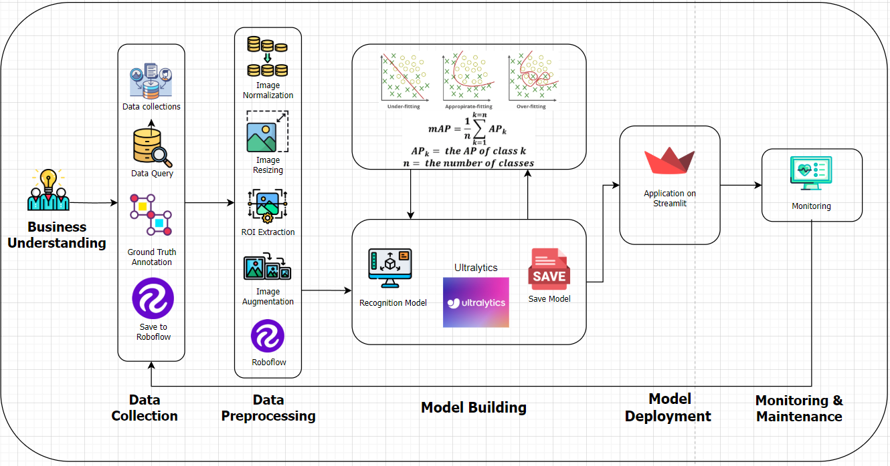



# PROJECT REFERENCES

|  |  |
| --- | --- |
| **Milestone** | **Deliverable** |
| Project Initiation and Setup | - Project scope definition - Infrastructure preparation |
| Data Collection and Preparation | - Collected datasets of road features (lane lines, damaged barriers) - Preprocessed and augmented data for training |
| Model Development and Training | |  | | --- | |  |  |  | | --- | | - YOLOv8s-seg model architecture - Initial trained model using the prepared dataset | |
| Model Evaluation and Optimization | - Evaluation report (mAP, IoU metrics) - Optimized model with tuned hyperparameters |
| Deployment and Integration | - Deployed YOLOv8s-seg model for real-time inspection - Integration with road inspection systems |

# 



# APPROVALS

**Prepared by** __________________________________

Project Manager

**Approved by** __________________

Project Sponsor

__________________________________

Executive Sponsor

__________________________________

Client Sponsor



# APPENDICES

## Document Guidelines

## Project Charter Document Sections Omitted

